#include <stdio.h>
#include <stdlib.h>

#define MAX_N 256 // Maximum value for n (adjustable)

// Function to compute (base^exp) % mod
int mod_pow(int base, int exp, int mod) {
int result = 1;
base = base % mod;
while (exp > 0) {
if (exp % 2 == 1)
result = (result * base) % mod;
exp = exp >> 1;
base = (base * base) % mod;
}
return result;
}

int is_in_coset(int *coset, int size, int value) {
int i;
for (i = 0; i < size; i++) {
if (coset[i] == value)
return 1;
}
return 0;
}

int main() {
int n, q;
int visited[MAX_N] = {0};

printf("Enter n (modulus): ");
scanf("%d", &n);
printf("Enter q (field base, e.g., 2): ");
scanf("%d", &q);

if (n >= MAX_N) {
printf("Error: n exceeds MAX_N = %d\n", MAX_N);
return 1;
}

printf("\nCyclotomic Cosets modulo %d over F_%d:\n", n, q);
int i;

for (i = 0; i < n; i++) {
if (!visited[i]) {
int coset[MAX_N];
int count = 0;
int val = i;

// Build the cyclotomic coset
do {
coset[count++] = val;
visited[val] = 1;
val = (val * q) % n;
} while (val != i);

// Print the coset
printf("C_%d = { ", i);
int j;
for (j = 0; j < count; j++) {
printf("%d", coset[j]);
if (j != count - 1)
printf(", ");
}
printf(" }\n");
}
}

return 0;
}
Output:
Enter n (modulus): 15
Enter q (field base, e.g., 2): 2

Cyclotomic Cosets modulo 15 over F_2:
C_0 = { 0 }
C_1 = { 1, 2, 4, 8 }
C_3 = { 3, 6, 12, 9 }
C_5 = { 5, 10 }
C_7 = { 7, 14, 13, 11 }

//program2
#include <stdio.h>
#include <math.h>

int main() {
int m;
printf("Enter m (degree of field extension F_{2^m}): ");
scanf("%d", &m);

int n = (1 << m) - 1; // n = 2^m - 1
int i, j, val;

printf("\nGenerating all cyclotomic cosets C_0 to C_%d over F_2 (mod %d):\n\n", n - 1, n);

for (i = 0; i < n; i++) {
printf("C_%d = { ", i);
val = i;
for (j = 0; j < n; j++) {
int c = (val * (1 << j)) % n; // i * 2^j mod n
printf("%d", c);
if (j != n - 1) printf(", ");
}
printf(" }\n");
}

return 0;
}
output:
Enter m (degree of field extension F_{2^m}): 3

Generating all cyclotomic cosets C_0 to C_6 over F_2 (mod 7):

C_0 = { 0, 0, 0, 0, 0, 0, 0 }
C_1 = { 1, 2, 4, 1, 2, 4, 1 }
C_2 = { 2, 4, 1, 2, 4, 1, 2 }
C_3 = { 3, 6, 5, 3, 6, 5, 3 }
C_4 = { 4, 1, 2, 4, 1, 2, 4 }
C_5 = { 5, 3, 6, 5, 3, 6, 5 }
C_6 = { 6, 5, 3, 6, 5, 3, 6 }

//unique cyclotomic cosets
#include <stdio.h>

#define MAX_N 1024

int cosets[MAX_N][MAX_N]; // Stores all cosets (temporary, max size)
int coset_sizes[MAX_N]; // Size of each coset
int is_representative[MAX_N]; // Mark if C_i is a unique representative

int main() {
int m;
printf("Enter m (degree of field extension F_{2^m}): ");
scanf("%d", &m);

int n = (1 << m) - 1; // n = 2^m - 1
int visited[MAX_N] = {0}; // Track which i's are already included in a coset
int total_unique_cosets = 0;

// Step 1: Build all cosets
int i;
for (i = 0; i < n; i++) {
if (!visited[i]) {
int count = 0;
int val = i;

do {
cosets[i][count++] = val;
visited[val] = 1;
val = (val * 2) % n;
} while (val != i);

coset_sizes[i] = count;
is_representative[i] = 1; // Mark this i as representative
total_unique_cosets++;
}
}

// Step 2: Print all unique cosets (only where is_representative[i] == 1)
printf("\nUnique cyclotomic cosets over F_2 modulo %d:\n", n);
int j;
for (i = 0; i < n; i++) {
if (is_representative[i]) {
printf("C_%d = { ", i);
for (j = 0; j < coset_sizes[i]; j++) {
printf("%d", cosets[i][j]);
if (j != coset_sizes[i] - 1)
printf(", ");
}
printf(" }\n");
}
}

printf("\nTotal unique cosets: %d\n", total_unique_cosets);
return 0;
}
Output:
Enter m (degree of field extension F_{2^m}): 3

Unique cyclotomic cosets over F_2 modulo 7:
C_0 = { 0 }
C_1 = { 1, 2, 4 }
C_3 = { 3, 6, 5 }

Total unique cosets: 3
#include <stdio.h>

#define MAX_N 1024

int cosets[MAX_N][MAX_N]; // C_0 to C_{n-1}, each coset is stored separately
int coset_sizes[MAX_N]; // size of each C_i

int main() {
int m;
printf("Enter m (degree of field extension F_{2^m}): ");
scanf("%d", &m);

int n = (1 << m) - 1; // n = 2^m - 1
int i,j;

// Build C_0 to C_{n-1} (with possible duplicates)
for (i = 0; i < n; i++) {
int count = 0;
int val = i;

do {
cosets[i][count++] = val;
val = (val * 2) % n;
} while (val != i);

coset_sizes[i] = count;
}

// Print all cosets C_0 to C_{n-1}
printf("\nCyclotomic cosets C_0 to C_%d over F_2 modulo %d (duplicates included):\n", n - 1, n);
for (i = 0; i < n; i++) {
printf("C_%d = { ", i);
for (j = 0; j < coset_sizes[i]; j++) {
printf("%d", cosets[i][j]);
if (j != coset_sizes[i] - 1)
printf(", ");
}
printf(" }\n");
}

return 0;
}
Output:
Enter m (degree of field extension F_{2^m}): 3

Unique cyclotomic cosets over F_2 modulo 7:
C_0 = { 0 }
C_1 = { 1, 2, 4 }
C_3 = { 3, 6, 5 }

Total unique cosets: 3

//program
#include <stdio.h>

#define MAX_N 1024

int cosets[MAX_N][MAX_N]; // C_0 to C_{n-1}, each coset is stored separately
int coset_sizes[MAX_N]; // size of each C_i

int main() {
int m;
printf("Enter m (degree of field extension F_{2^m}): ");
scanf("%d", &m);

int n = (1 << m) - 1; // n = 2^m - 1
int i,j;

// Build C_0 to C_{n-1} (with possible duplicates)
for (i = 0; i < n; i++) {
int count = 0;
int val = i;

do {
cosets[i][count++] = val;
val = (val * 2) % n;
} while (val != i);

coset_sizes[i] = count;
}

// Print all cosets C_0 to C_{n-1}
printf("\nCyclotomic cosets C_0 to C_%d over F_2 modulo %d (duplicates included):\n", n - 1, n);
for (i = 0; i < n; i++) {
printf("C_%d = { ", i);
for (j = 0; j < coset_sizes[i]; j++) {
printf("%d", cosets[i][j]);
if (j != coset_sizes[i] - 1)
printf(", ");
}
printf(" }\n");
}

return 0;
}
Output:
Enter m (degree of field extension F_{2^m}): 3

Cyclotomic cosets C_0 to C_6 over F_2 modulo 7 (duplicates included):
C_0 = { 0 }
C_1 = { 1, 2, 4 }
C_2 = { 2, 4, 1 }
C_3 = { 3, 6, 5 }
C_4 = { 4, 1, 2 }
C_5 = { 5, 3, 6 }
C_6 = { 6, 5, 3 }

Different ways of writing the below block
int val = i;
do {
all_cosets[i][count++] = val; // store value
val = (val * 2) % n; // move to next power of 2
} while (val != i); // stop when it loops .

1. Using a while (1) with break
int val = i;
while (1) {
all_cosets[i][count++] = val;
val = (val * 2) % n;
if (val == i) break;
}
Same result — just a different looping style using an infinite loop and a break.

2. Using for loop style manually
int val = i;
for (;;) {
all_cosets[i][count++] = val;
val = (val * 2) % n;
if (val == i) break;
}
Also equivalent, but expressed using an infinite for loop.

3. Do it once outside, then use while
int val = i;
all_cosets[i][count++] = val;
val = (val * 2) % n;
while (val != i) {
all_cosets[i][count++] = val;
val = (val * 2) % n;
}
This explicitly stores the first value outside, and handles the rest in the loop. Some people prefer this to make the loop simpler.

4. Using a helper function (if reused elsewhere)
If you like modular code:
int generate_coset(int *coset, int base, int n) {
int count = 0;
int val = base;
do {
coset[count++] = val;
val = (val * 2) % n;
} while (val != base);
return count;
}
And then call:
all_coset_sizes[i] = generate_coset(all_cosets[i], i, n);
This separates logic cleanly, and can be reused or tested independently.

Summary
All these:
- Do the exact same cyclotomic coset generation
- Use different syntax styles or structure
- It’s mostly about readability, reusability, or personal preference

Step 1: Polynomial Multiplication in F2​[x]
We represent polynomials as uint32_t integers:
- Bit position = exponent of xxx
- Bit value = coefficient (0 or 1)
For example:
- 0b11 = x+1x + 1x+1
- 0b101 = x2+1x^2 + 1x2+1

Function: Multiply two polynomials in F2​[x]
// Multiply two polynomials over F_2 (no mod reduction yet)
uint32_t poly_mul_f2(uint32_t a, uint32_t b) {
uint32_t result = 0;
while (b) {
if (b & 1) {
result ^= a; // XOR = addition in F_2
}
a <<= 1; // Multiply a by x
b >>= 1; // Move to next bit of b
}
return result;
}

Example Usage:
uint32_t p1 = 0b11; // x + 1
uint32_t p2 = 0b101; // x^2 + 1

uint32_t prod = poly_mul_f2(p1, p2);
// Expected: (x + 1)(x^2 + 1) = x^3 + x^2 + x + 1 = 0b1111

Step 2: computing αj\alpha^jαj

What Are We Doing?
We need a function to compute:
αjmod f(x)\alpha^j \mod f(x)αjmodf(x)
Where:
- α\alphaα: the first primitive element, e.g., alpha = primitive_elements[0]
- jjj: integer exponent
- f(x): your irreducible polynomial (as binary, e.g., 0b1011)
- All arithmetic is in F2m\mathbb{F}_{2^m}F2m​

Function: Exponentiation in F2m\mathbb{F}_{2^m}​
// Compute alpha^exp modulo the irreducible polynomial over F_2
uint32_t pow_alpha(uint32_t alpha, int exp, uint32_t mod, int m) {
uint32_t result = 1;
int i;
for (i = 0; i < exp; i++) {
result = poly_mult_mod(result, alpha, mod, m);
}
return result;
}
- alpha: base element
- exp: exponent j
- mod: irreducible polynomial
- m: field degree
This uses your already-working poly_mult_mod() from earlier.

Example Usage
uint32_t alpha = primitive_elements[0]; // your chosen α
uint32_t a_pow_3 = pow_alpha(alpha, 3, mod_poly, m);
// This gives α^3 mod f(x)

Code to Print alpha^i for All i
printf("\nPowers of alpha (primitive element):\n");
for (int i = 0; i < n; i++) {
uint32_t a_pow_i = pow_alpha(alpha, i, mod_poly, m);

printf("alpha^%2d = ", i);
print_binary(a_pow_i, m);
printf(" (decimal: %d)\n", a_pow_i);
}
// Computes alpha^exp in F_{2^m} using repeated multiplication
uint32_t pow_alpha(uint32_t base, int exp, uint32_t mod, int m) {
uint32_t result = 1;
for (int i = 0; i < exp; i++) {
result = poly_mult_mod(result, base, mod, m);
}
return result;
}

Example Output (for m=3, α=x\alpha = x p(x) = x^3 + x + 1
alpha^ 0 = 001 (decimal: 1)
alpha^ 1 = 010 (decimal: 2)
alpha^ 2 = 100 (decimal: 4)
alpha^ 3 = 011 (decimal: 3)
alpha^ 4 = 110 (decimal: 6)
alpha^ 5 = 111 (decimal: 7)
alpha^ 6 = 101 (decimal: 5)

Step 3: building and multiplying all (x−αj)(x - \alpha^j)(x−αj) for j∈Cij \in C_ij∈Ci​ to compute the minimal polynomial:
M(i)(x)=∏j∈Ci(x−αj)M^{(i)}(x) = \prod_{j \in C_i} (x - \alpha^j)M(i)(x)=j∈Ci​∏​(x−αj)

What's Going On?
- You already have:
  - Primitive element α\alphaα
  - Cyclotomic cosets: cosets[i][j] and coset_sizes[i]
  - Exponentiation: pow_alpha(alpha, j, mod_poly, m) gives αj\alpha^jαj
- We want to multiply all (x−αj)(x - \alpha^j)(x−αj) together in F2[x]\mathbb{F}_2[x]F2​[x]

tep-by-Step Plan
Step 3.1: Represent a Polynomial
Use an array of uint32_t where poly[k] is the coefficient of xkx^kxk.
Example:
- Polynomial x2+x+1x^2 + x + 1x2+x+1 → {1, 1, 1}

Step 3.2: Multiply Two Polynomials in F2\mathbb{F}_2F2​
void poly_mult_f2(uint32_t *a, int deg_a, uint32_t *b, int deg_b, uint32_t *result) {
for (int i = 0; i <= deg_a + deg_b; i++)
result[i] = 0;

for (int i = 0; i <= deg_a; i++) {
for (int j = 0; j <= deg_b; j++) {
result[i + j] ^= (a[i] & b[j]); // XOR in F2
}
}
}

Step 3.3: Build M(i)(x)=∏j∈Ci(x−αj)M^{(i)}(x) = \prod_{j \in C_i} (x - \alpha^j)M(i)(x)=∏j∈Ci​​(x−αj)
void build_minimal_poly(int *coset, int size, uint32_t alpha, uint32_t mod_poly, int m) {
// Initialize to (x - alpha^coset[0])
uint32_t a_pow = pow_alpha(alpha, coset[0], mod_poly, m);
uint32_t current[64] = {1, a_pow}; // (x - a^j) = x + a^j in F2
int current_deg = 1;

uint32_t temp[128]; // Temp for multiplication

for (int i = 1; i < size; i++) {
a_pow = pow_alpha(alpha, coset[i], mod_poly, m);
uint32_t next[64] = {1, a_pow}; // (x - a^j)

poly_mult_f2(current, current_deg, next, 1, temp);

// Copy temp back to current
current_deg += 1;
for (int j = 0; j <= current_deg; j++) {
current[j] = temp[j];
}
}

// Print M^(i)(x)
printf("M^(%d)(x) = ", coset[0]);
for (int i = current_deg; i >= 0; i--) {
if (current[i]) {
if (i == 0)
printf("1");
else if (i == 1)
printf("x + ");
else
printf("x^%d + ", i);
}
}
printf("\n");
}

Usage
Inside main() after building cosets and primitive element:
for (int i = 0; i < n; i++) {
if (coset_sizes[i] == 0) continue; // skip unused slots
build_minimal_poly(cosets[i], coset_sizes[i], alpha, mod_poly, m);
}

Output Example (for m=3, primitive poly 1011)
M^(0)(x) = x + 1
M^(1)(x) = x^3 + x + 1
M^(3)(x) = x^3 + x^2 + 1

Goal
For each cyclotomic coset CiC_iCi​, compute:
M(i)(x)=∏j∈Ci(x−αj)M^{(i)}(x) = \prod_{j \in C_i} (x - \alpha^j)M(i)(x)=j∈Ci​∏​(x−αj)
using your primitive element α\alphaα and previously computed cosets.

Helper Functions First
#include <stdio.h>
#include <stdint.h>

#define MAX_DEGREE 64
#define MAX_N 128

// Multiply two field elements in F_{2^m} modulo the irreducible polynomial
uint32_t poly_mult_mod(uint32_t a, uint32_t b, uint32_t mod, int m) {
uint32_t result = 0;
while (b) {
if (b & 1) result ^= a;
a <<= 1;
if (a & (1 << m)) a ^= mod;
b >>= 1;
}
return result;
}

// Compute alpha^j in F_{2^m}
uint32_t pow_alpha(uint32_t alpha, int j, uint32_t mod, int m) {
uint32_t result = 1;
for (int i = 0; i < j; i++) {
result = poly_mult_mod(result, alpha, mod, m);
}
return result;
}

// Multiply two polynomials in F2[x] (bitwise XOR for addition)
void poly_mult_f2(uint32_t *A, int degA, uint32_t *B, int degB, uint32_t *R) {
for (int i = 0; i <= degA + degB; i++) R[i] = 0;

for (int i = 0; i <= degA; i++) {
for (int j = 0; j <= degB; j++) {
R[i + j] ^= A[i] & B[j];
}
}
}

Main Function to Build Minimal Polynomial M(i)(x)M^{(i)}(x)M(i)(x)
// Build minimal polynomial from a coset C_i
void build_minimal_poly(int *coset, int size, uint32_t alpha, uint32_t mod_poly, int m) {
uint32_t result[MAX_DEGREE] = {0};
uint32_t temp[MAX_DEGREE];

// Start with first term (x + alpha^j)
uint32_t a_j = pow_alpha(alpha, coset[0], mod_poly, m);
result[0] = a_j; // Constant term
result[1] = 1; // x term
int degree = 1;

for (int i = 1; i < size; i++) {
uint32_t factor[2];
a_j = pow_alpha(alpha, coset[i], mod_poly, m);
factor[0] = a_j;
factor[1] = 1;

poly_mult_f2(result, degree, factor, 1, temp);

// Copy temp to result
degree += 1;
for (int k = 0; k <= degree; k++) {
result[k] = temp[k];
}
}

// Print the polynomial
printf("M^(%d)(x) = ", coset[0]);
for (int i = degree; i >= 0; i--) {
if (result[i]) {
if (i == 0) printf("1");
else if (i == 1) printf("x");
else printf("x^%d", i);

// Add '+' if not the last term
if (i > 0) printf(" + ");
}
}
printf("\n");
}

How to Use It in main()
After you've built:
- cosets[i][j] = array of cyclotomic cosets
- coset_sizes[i] = size of each coset
- alpha = primitive element
Add this:
for (int i = 0; i < n; i++) {
if (coset_sizes[i] == 0) continue;
build_minimal_poly(cosets[i], coset_sizes[i], alpha, mod_poly, m);
}

Sample Output (for m = 3, irreducible = 1011):
M^(0)(x) = x + 1
M^(1)(x) = x^3 + x + 1
M^(3)(x) = x^3 + x^2 + 1

math behind multiplying two polynomials over F2\mathbb{F}_2F2​ (binary field), and why the code uses XOR and AND operations.
Background: Polynomial Multiplication
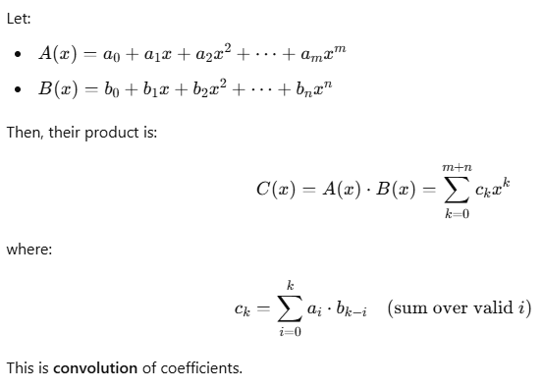
Now Over F_2 (Binary)
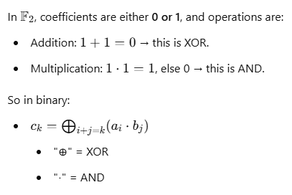
Example: Multiply
A(x) = x + 1 → [1, 1] (a0 = 1, a1 = 1)
B(x) = x^2 + x → [0, 1, 1] (b0 = 0, b1 = 1, b2 = 1)
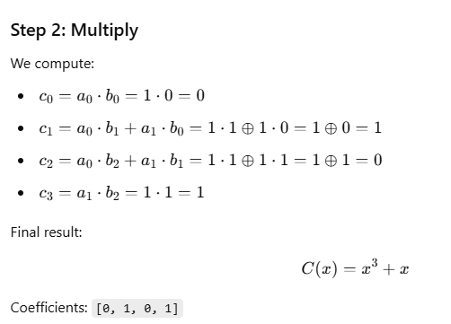
Corresponding code logic:
void poly_mult_f2(uint32_t *A, int degA, uint32_t *B, int degB, uint32_t *R) {
for (int i = 0; i <= degA + degB; i++) R[i] = 0;

for (int i = 0; i <= degA; i++) {
for (int j = 0; j <= degB; j++) {
R[i + j] ^= A[i] & B[j]; // XOR for addition, AND for multiplication
}
}
}
This follows the rule:
- Multiply: A[i] & B[j]
- Add: ^= (XOR)
why we have both poly_mult_mod and polynomial multiplication functions, and how they differ in purpose, even though they seem similar.

poly_mult_mod — For Field Element Multiplication
This function is used to multiply elements of the field {F}_{2^m}​, represented as binary numbers.
Purpose:
- Multiply two field elements (like α3⋅α5\alpha^3 \cdot \alpha^5α3⋅α5) in {F}_{2^m}F
- Reduce the result modulo the irreducible polynomial p(x) (so the result is still inside the field)
Input/Output:
- Input: 32-bit integers a and b (elements of the field)
- Output: 32-bit integer (result in the field)
Internally:
- It shifts bits and XORs, simulating multiplication of polynomials followed by modulo reduction.

poly_mult_f2 — For Symbolic Polynomial Multiplication
This function is used when you're working with actual polynomials like:
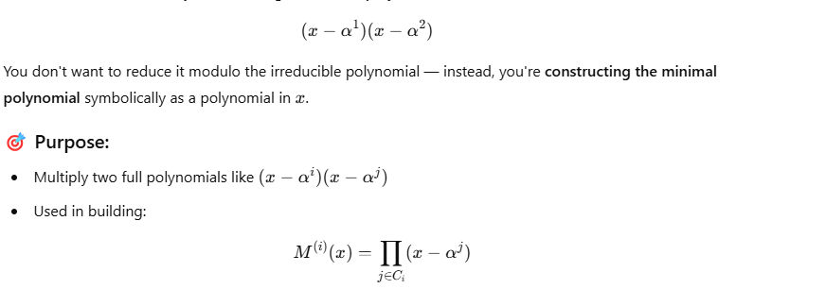
Input/Output:
- Input: Arrays of coefficients for polynomials
- Output: Resultant polynomial as another array of coefficients
Internally:
- Uses AND for multiplying coefficients
- Uses XOR for adding coefficients
- No modulo reduction by irreducible polynomial
Example of Why Both Are Needed
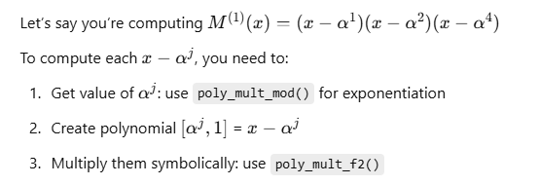
Example: Construct
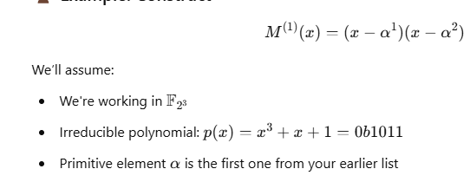
Step 1: Computing alpha^1 , alpha^2 using poly_mult_mod
uint32_t alpha = primitive_elements[0]; // e.g., alpha = 0b10 (binary for x)

uint32_t a1 = poly_mult_mod(alpha, 1, 0b1011, 3); // α^1
uint32_t a2 = poly_mult_mod(alpha, alpha, 0b1011, 3); // α^2
Let’s say:
- α^1=0b10 (which is x)
- α^2=0b100(Which isx^2)
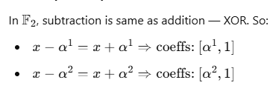
Represent them as arrays:
uint32_t poly1[2] = {a1, 1}; // (x + α^1)
uint32_t poly2[2] = {a2, 1}; // (x + α^2)
uint32_t result[3]; // Degree 2 result

Step 3: Multiply using poly_mult_f2()
void poly_mult_f2(uint32_t *a, int deg_a, uint32_t *b, int deg_b, uint32_t *res) {
int i, j;
for (i = 0; i <= deg_a + deg_b; i++)
res[i] = 0;

for (i = 0; i <= deg_a; i++) {
for (j = 0; j <= deg_b; j++) {
res[i + j] ^= poly_mult_mod(a[i], b[j], mod_poly, m); // Multiply in F_{2^m}
}
}
}
Now call
poly_mult_f2(poly1, 1, poly2, 1, result);
Result:
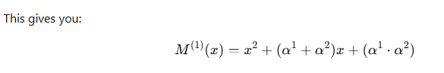
And it's stored in result[0], result[1], result[2]
You can print it like:
for (int i = 2; i >= 0; i--) {
printf("%s", i == 2 ? "" : " + ");
printf("(");
print_binary(result[i], m);
printf(")x^%d", i);
}

-------
// Computes alpha^exp in F_{2^m} using repeated multiplication
uint32_t pow_alpha(uint32_t base, int exp, uint32_t mod, int m) {
uint32_t result = 1;
for (int i = 0; i < exp; i++) {
result = poly_mult_mod(result, base, mod, m);
}
return result;
}
printf("\nPowers of alpha (primitive element):\n");
for (int i = 0; i < n; i++) {
uint32_t a_pow_i = pow_alpha(alpha, i, mod_poly, m);

printf("alpha^%2d = ", i);
print_binary(a_pow_i, m);
printf(" (decimal: %d)\n", a_pow_i);
}
Outpu:
alpha^ 0 = 001 (decimal: 1)
alpha^ 1 = 010 (decimal: 2)
alpha^ 2 = 100 (decimal: 4)
alpha^ 3 = 011 (decimal: 3)
alpha^ 4 = 110 (decimal: 6)
alpha^ 5 = 111 (decimal: 7)
alpha^ 6 = 101 (decimal: 5)

